Clip It! Behavior Chart
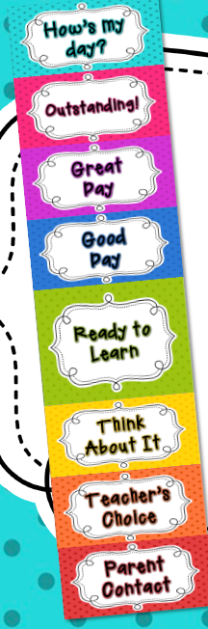
Your child will be asked to follow rules and procedures in and out of our classroom. Our classroom will use a clip chart to monitor behavior. A clip chart is a great tool that allows students to be rewarded for positive behavior, while discouraging negative behavior.
Each student has a clothespin with his or her name on it. Everyone will start on green at the beginning of each day and clips can be moved up and down throughout the day based on behavior.
The following describes each level:
Outstanding: This level is reserved for exceptional behavior. A student who reaches this level will earn a special note home and a jewel on his/her clip. After five jewels, clips will be retired to the Hall of Fame and a new clip will be given!
Great Day: Students can move to the Great Day level for continuing to display good behavior. You should be very proud of your child for reaching this level!
Good Day: Students will move to the Good Day level for showing they are making the right behavior decisions! Ending the day on this level is great!
Ready to Learn: Every student will start the day on the Ready to Learn level. As the day goes on, clips can be moved up and down, based on behavior. This is a good one to be on!
Think About It: A student will be moved to the Think About It level as a warning about his/her behavior, and a reminder to follow the rules.
Teacher’s Choice: Students who continue to display poor behavior can move down to the Teacher’s Choice level. Here, the teacher will decide what action to take. Loss of recess, center time, or other privileges might be an appropriate choice.
Parent Contact: When a student moves to the Parent Contact level, the teacher will notify parents via note, email, or phone call. A visit to the Principal’s office might also be in order. Students on this level may also lose recess time, etc.
Remember that this program is just a guide. Special circumstances may call for adjustments as needed.
Please check with your child daily about his/her day. The students will log what color they end up on each day in their “How was your day?” folder. Please be watching for their folder that will come home at the end of each week. You will need to initial the calendar in the Saturday box and return the folder the following Monday. Also, each student will get to put a ticket in the jar for every day that they stay above the ready to learn tab. Once the class reaches 700 tickets we will have a classroom behavior party to help celebrate the wonderful behavior.
Don’t hesitate to contact me with questions. This program is new for me too. I like the concept that the kids can be rewarded in addition to just receiving consequences for their behavior. I will keep you informed of any major changes made to our behavior program.
Thanks so much for your anticipated support of this program!
~Mrs. Balogh

